**PROJECT 2- GROUP 3**

## **Project Title**

Houston Real Estate Investment Interactive Dashboard

## **Team Members**

* Jonathan Antia Barrero
* Adriana Ovalle
* Ellen Rud

## **Project Description/ Outline**

Real Estate investment research is time consuming because of the lack of a single place to find all the information related to home value tendencies, school ratings, flood zones, crime rate and amount of transactions happening per zip code in Houston. The following project responds to an investor with a ranking of Zip Codes in the Houston area to invest in.

## **Project Plan**

The development of the code will include the following items:

* SQL Database
* Python Flask -powered RESTful API, HTML/CSS
* HTML, CSS and JavaScript

## **GitHub Repository**

<https://github.com/JonathanAntia/Group3_Project2>

## **Data Sources**

* School Ratings:
  + Source: <https://texasschoolguide.org/school-rankings/>
  + Download: CSV file
* National Flood Data:
  + Source: <http://nationalflooddata.com/flood/floodapi/>
  + Web request API using street addresses from HCAD dataset
* Harris County Appraisal District (HCAD):
  + Source: <https://pdata.hcad.org/download/2019>
  + Download: ZIP folders comprised of text files and csv files
* Crime:
  + Source: <https://www.houstontx.gov/police/cs/Monthly_Crime_Data_by_Street_and_Police_Beat.htm>
  + Download: CSV file

**Files location:** <https://drive.google.com/drive/folders/15sKnJGCKU_VsG290i97kzsAnyc1tFNNT>

## **Entity-Relation Diagram**

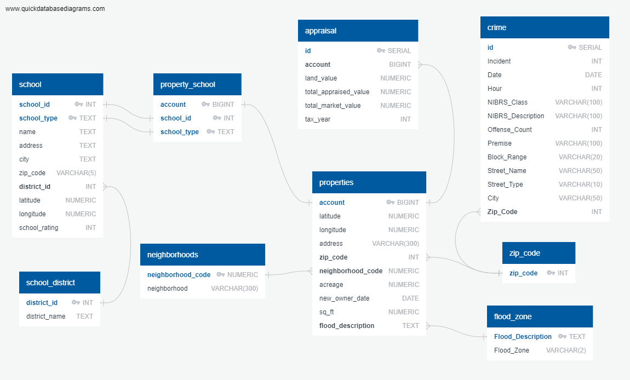

## **Mock-Ups of Application**

## Landing Page (route 1)

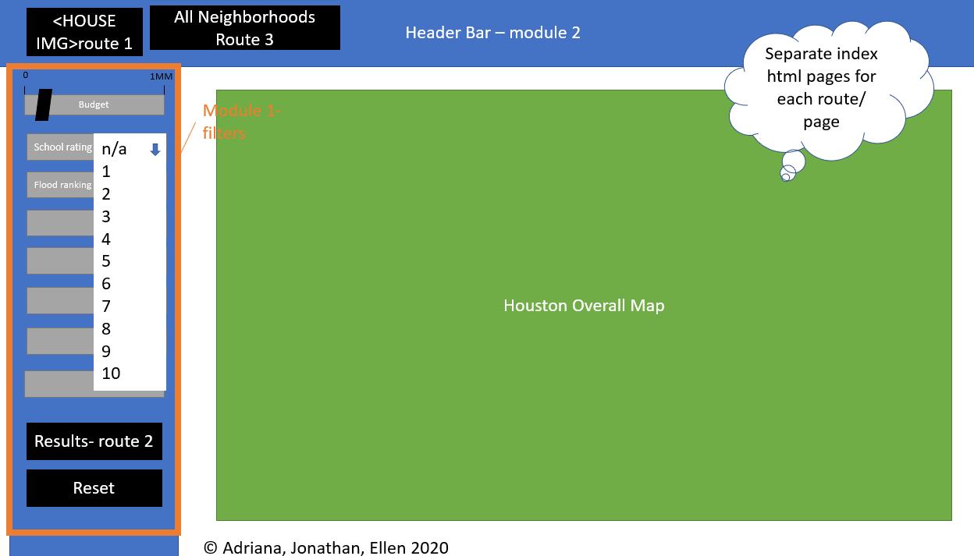

## Results Page- Full Screen Version (route 2)

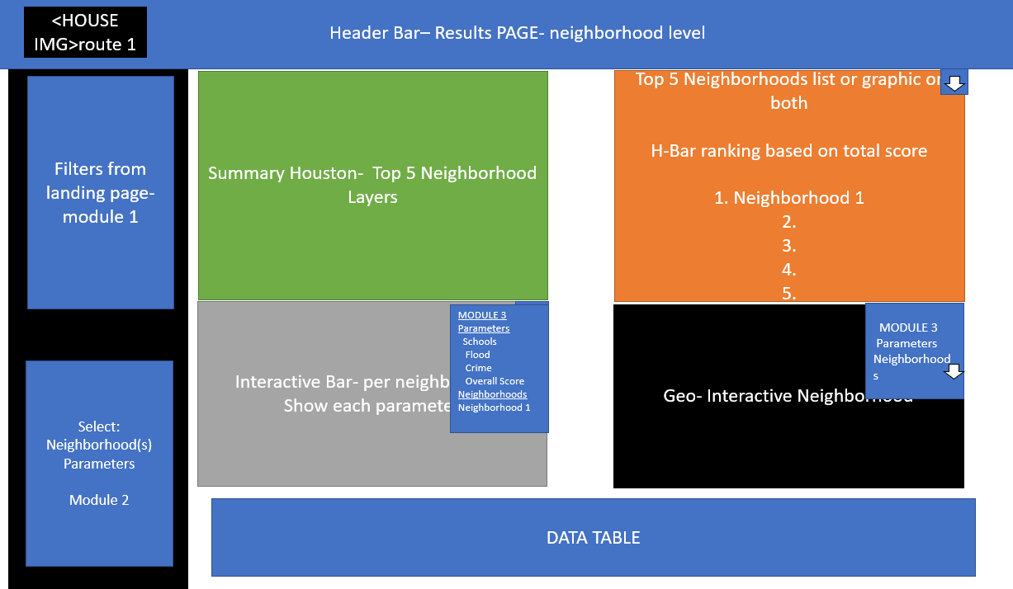

## Results Page- Mobile Version

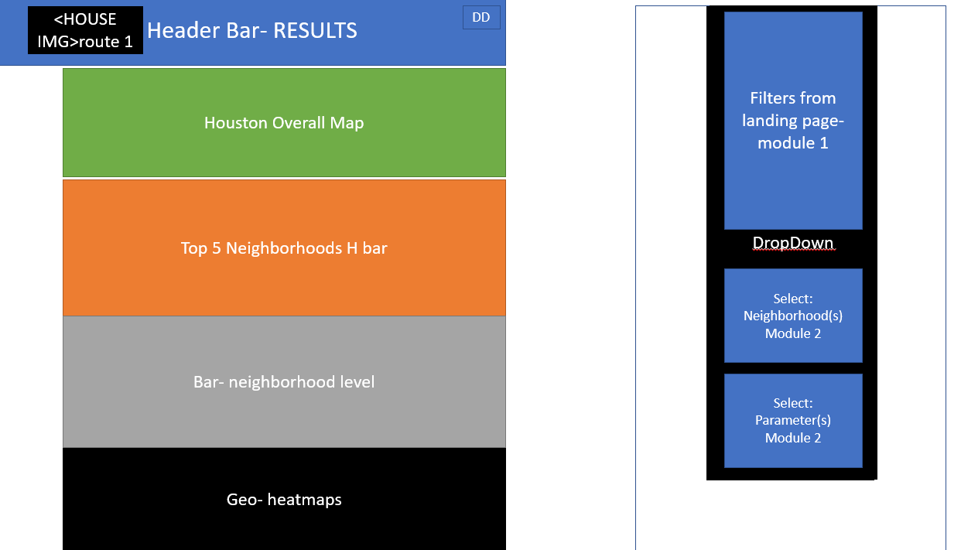

## Results Page- All neighborhoods (route 3)

This results from filters applied in route 2: Select Neighborhood Parameters

